**Selenium Grid:**

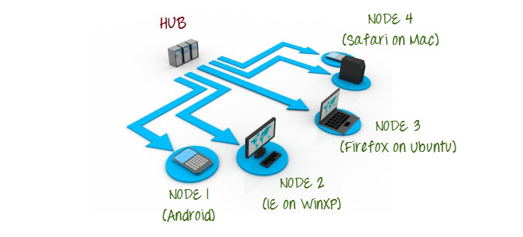

**HUB:**

HUB is a central server through which u can execute different test cases and selenium code on different servers. And can run test cases parallel.

**To work with selenium Grid:**

To need to download selenium server. (jar file)

[Downloads | Selenium](https://www.selenium.dev/downloads/)

**Steps:**

1. Download selenium grid/server

* Registering hub
* Started the hub
* Command cmd - cd ..

C:\> java - jar [folderSeleniumGrid/selenium grid filename].jar hub

* Started the hub
* To launched the server.

Command: [http://192.168.1.103:44**/grid/console](http://192.168.1.103:44**/grid/console)